Sleep Duration Analysis Project

STAT 301 ANOVA – Spring 2026
Group Name: Abdimajid Aden, Natnael Berhanu

Introduction

For this project, we used the Sleep Health and Lifestyle dataset In Kaggle. The original dataset has 400 rows and 13 columns and includes information about sleep habits, occupation, gender, physical activity, stress, BMI, heart rate, daily steps, and sleep disorders. For our updated dataset for the project, we used a cleaned version of the data with 335 observations. We focused on Sleep Duration as the outcome variable and used Occupation and Gender as the grouping variables because they match our research questions. This dataset helps us see if people sleep depending on what group they belong to.

Research Questions

- Does sleep duration differ between different occupations?
- Does sleep duration differ between males and females?
- Does sleep duration differ based on both gender and occupation, and is there an interaction between them?

Variables

In this study, the main variable we wanted to explain was Sleep Duration. Sleep Duration means the average number of hours a person sleeps each day. This variable is numeric because it is measured with numbers, such as 6.5 hours, 7 hours, or 8 hours.

The dependent variable in this study is Sleep Duration; it measures the average hours of sleep a person gets and is a numeric variable. The independent variables are Occupation and Gender, which are both categorical variables. In our cleaned data, Occupation has five groups
The variables we used to make comparisons were Occupation and Gender. These are categorical variables because they put people into groups. In our cleaned dataset, Occupation had five groups, which were Accountant, Engineer, Healthcare, Lawyer, and Teacher. This variable tells us what type of job each person has.
Gender had two groups, which were Female and Male. This variable tells us the gender group of each person in the dataset.
We chose these variables because sleep is important in everyday life and it can affect a person’s health, energy, and stress. We wanted to use Sleep Duration because it shows how much sleep people are getting on average. We chose Occupation because different jobs can have different schedules, workloads, and stress levels, which may affect how much sleep a person gets. We also chose Gender because males and females may have different lifestyle patterns, health factors, or responsibilities that could be related to sleep.

Hypotheses

Research Question 1

$H_{0}$: $μ_{Accountant} = μ_{Engineer} = μ_{Healthcare} = μ_{Lawyer} = μ_{Teacher}$
$H_{a}$: At least one meaning is different

Research Question 2

$H_{0}$: $μ_{Male}=μ_{Female}$
$H_{a}$: $μ_{Male}≠μ_{Female}$

Research Question 3

$$H_{0} :μ_{Male},_{Accountant}=μ_{Female},_{Accountant}=μ_{Male},_{Enginner}=μ_{Female},_{Enginner }=μ_{Male},_{Healthcare }=μ_{Feale},_{Healthcare }=μ_{Male},_{Lawyer}=μ_{Female},_{Lawyer}=μ_{Male},_{Teacher}=μ_{Female},_{Teacher}$$
$$H_{a}:not all these differnece are eqaul$$

Methods

We used ANOVA to analyze the data. A one-way ANOVA was used for Research Question 1 and Research Question 2 because each question has one categorical independent variable and one numeric dependent variable. A two-way ANOVA was used for Research Question 3 because it includes two categorical independent variables, Gender and Occupation, and it tests both their main effects and their interaction on Sleep Duration.

ANOVA is appropriate for this project because Sleep Duration is a numeric variable, while Gender and Occupation are categorical variables. This makes ANOVA a good method for comparing mean sleep duration across groups.

Before running the analysis, we cleaned the dataset by keeping only the variables needed for this study. The final dataset included Sleep Duration, Occupation, and Gender. We used the cleaned version of the data with 335 observations and focused on the five occupation groups included in our final analysis.

Results

Research Question 1

Figure 1 Table
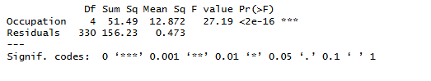
We used a one-way ANOVA to test whether average sleep duration is different across occupations. The test was statically significant different

F (4, 330) = 27.19, p < 0.001.

Since the p value is less than 0.05, we reject the null hypothesis. This means sleep duration is not the same for all occupation groups, and at least one group has a different average. This shows that a person’s job may be linked to how much sleep they usually get.

Figure 1. Mean Sleep Duration by Occupation

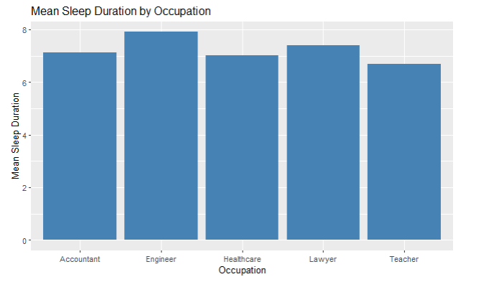

Figure 1 shows the mean sleep duration for each occupation group. Engineers have the highest average sleep duration, while teachers have the lowest. Accountants and healthcare workers have similar averages, and lawyers fall between those groups. This pattern supports the ANOVA result and shows that sleep duration changes across occupations. This suggests that the kind of job a person has may be related to how much sleep they get.

Research Question 2

Figure 2 Table
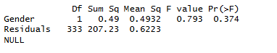

We conducted a one-way ANOVA to test whether average sleep duration differs between males and females. The test was not statistically significant, F (1, 333) = 0.793, p = 0.374. Since the p value is greater than 0.05, we fail to reject the null hypothesis. This means there is not enough evidence to say that males and females differ in average sleep duration. This suggests that gender alone is not a strong predictor of sleep duration in this dataset.

Figure 2. Mean Sleep Duration by Gender

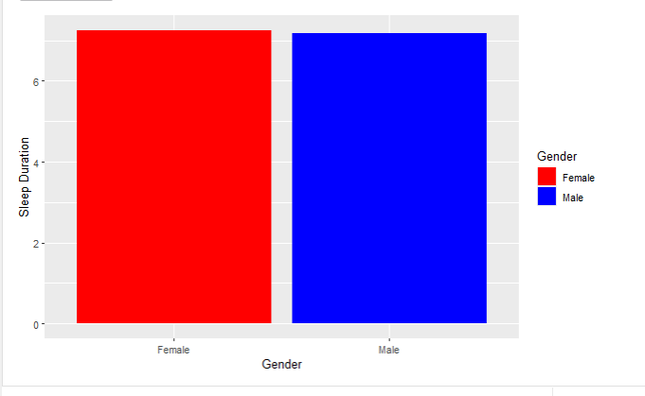

Figure 2 shows the mean sleep duration for females and males. The two averages are very close, which matches the ANOVA result and suggests there is no clear difference in sleep duration by gender. This makes it seem like gender by itself is not an important factor in explaining sleep duration in this dataset. The graph also shows that both groups get about the same amount of sleep on average.

Research Question 3
Figure 3 Table
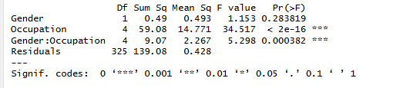

We conducted a two-way ANOVA to examine the effects of gender, occupation, and their interaction on sleep duration. The results showed:

- Gender was not significant: F (1, 325) = 1.153, p = 0.284
- Occupation was significant: F (4, 325) = 34.517, p < 0.001.
- Interaction was significant: F (4, 325) = 5.298, p < 0.001.

Since the interaction p-value is less than 0.05, we reject the null hypothesis. This means that there is a significant interaction between gender and occupation. This means the effect of occupation on sleep duration depends on gender

Figure 3. Interaction Plot of Gender and Occupation on Sleep Duration

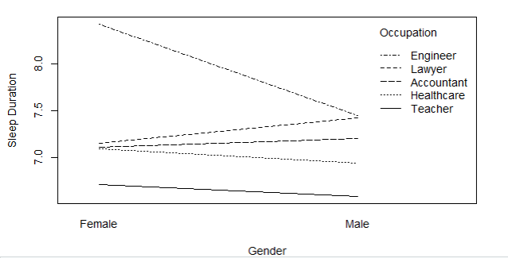

Figure 3 shows the interaction between gender and occupation on sleep duration. The lines are not parallel, which suggests that the effect of occupation on sleep duration is different for males and females. For example, engineers have a noticeably higher average sleep duration for females than for males, while the other occupation groups follow different patterns. This supports the two-way ANOVA result and shows that sleep duration is affected by more than just one factor at a time.

Conclusion

In this study, we found that occupation has a significant effect on sleep duration, while gender alone does not. We also found a significant interaction between gender and occupation, which means the effect of occupation on sleep duration is different for males and females.
The most interesting finding is that gender was not significant by itself, but the interaction between gender and occupation was significant. This suggests that sleep duration is shaped by more than one factor working together.
One limitation of this analysis is that we only included a few variables. Other factors such as stress level, physical activity, and lifestyle may also affect sleep duration. In addition, some occupation groups may have smaller sample sizes, which could affect the results.

We chose this dataset because it connects to real-life health and lifestyle habits. Sleep is something that affects everyone, and the dataset gave us a way to compare sleep duration between different groups of people. Since the dataset had a numeric sleep variable and categorical group variables, it worked well for ANOVA.

Overall, this study shows that occupation plays an important role in sleep duration, and that the relationship becomes more complex when gender is considered with occupation.

GitHub link

Natnael Berhanu: https://github.com/Natnael010/STAT-301-Sleep-Duration-ANOVA-Project.git

